**CHAPTER 1: PROJECT DEFINITION**

**1. Introduction**

Companies use information as a weapon in the battle to increase

productivity, deliver quality products and services, maintain customer loyalty, and

make sound decisions. Information technology can mean the difference between

success and failure. An Online Management System is both creative and technical

advantageous aspects in the world of internet, including the design, advertising,

sales and development. It is now being used by many companies, including those

companies which competing in the world of business. As the technology keep

changing and many companies are still adapting techniques to produce much

revenue, Internet marketing technologies can broaden the scope of business both

on local and global competencies.

Jubecer Security Service, Inc. is an organization, which provides armed

security services and expertise to private and public clients located at Unit 6.G/F.

Corner Complex Bldg. #12 New York St. Brgy. Immaculate Conception, Cubao,

Quezon City. They deploy trustworthy and well trained securities to protect

establishments. They provide high quality security service to clients. They also

employ security and lady guards and train them to be fit to line of work. Jubecer

Security Service is responsible for making the contract between the applicant and

the client.

The primary goal of the company is to maintain the good relationship to the

customers by providing a quality services. The company is constantly changing

that’s why providing an excellence services and strong partnership with dealers

and customers are the satisfactory of company’s image.

The company is used to have a process of manual transactions with their

clients and employees where in the client/s inquire for services by approaching

the agency. The client/s have to go to the agency and submit the requirements.

Same rule applies for the employee Application.

Online Management Information System will improve the current system of

the company. Online Management Information System reaches the costumer and

employees easily throughout the internet that serves as the progress to their

existing system.

In relation to this, the researchers will develop Jubecer Client and Security

Guards Information System for a hassle-free transaction not only for the

consumers but for the company employees as well. This will provide modules for

ordering, security, maintenance, tracking and reports. For security purposes, the

system will have three (3) level of access. This will be the Administrator/s,

Employees and Customers. Only Administrator has the authority to configure the

site, add/update/delete products, block suspicious Clients, view contracts and

generate reports. Employees and Customers can view the view the services

offered by the company and can inquire for service and employ to the company.

This security together with the log-in module will limit the access of non-

administrator, thus protecting the important data from hackers. For account

protection of the registered users, passwords will be encrypted upon saving into

database. In case the members forgot their password, the system will provide a

link to reset the password which will be sent only to the member’s email. For

Guests, they can easily sign up to the site by filling up the form provided in the

Registration Page. Personal information, log-in details and email are required

fields.

Aside from Security, Log-in, Forgot Password and Registration modules,

the system will also provide a mobile application. This will offer an easy-browsing

services offered by the company. Ordering can be done just by only few clicks on

your mobile phones. Online Employment for employees can only also be done

through mobile phones almost the same as inquiring for services.

**2. BUSINESS CASE**

**2.1 BACKGROUND OF THE ORGANIZATION**

Jubecer Security Service, Inc. is an organization, which provides armed

security services and expertise to private and public clients located at Unit 6.G/F.

Corner Complex Bldg. #12 New York St. Brgy. Immaculate Conception, Cubao,

Quezon City. They deploy trustworthy and well trained securities to protect

establishments. They provide high quality security service to clients. They also

employ security and lady guards and train them to be fit to line of work. Jubecer

Security Service is responsible for making the contract between the applicant and

the client.

JUBECER SECURITY SERVICES, INC. Is a duly organized and registered

by virtue of the Laws of the Republic of the Philippines with Securities and

Exchange Commission Registration Number CS20160595 and licensed with the

Philippine National Police – Supervisory Office for Security and Investigation

Agencies(PNP-SOSIA) under PAS-T-00121-2016 as a private Security Agency

authorized to operate nationwide, and Member of Philippine Association of

Detective and Protective Agency Operators(PADPAO).

**2.2 PROJECT OVERVIEW**

The project will be focusing on making a computerize way on how Jubecer will manage their entire business transactions. The said project will be an web-based management system. It is an online management system with different modules designed to help the agency easily manage their works at least cost and efforts. Those modules include the online service inquiry for their clients, online employment application for the security guards and reports generation module. The system will also contain modules to handle other business transactions such as security guard deployment, leave request for the guards, contract termination for the clients and resignations for the security guards. Also the system provides maintenance module for ease handling and maintaining of the agency’s business data and information. The system also includes a mobile application for both clients and security guards for easy and better service. The said mobile application can be used to notify the clients and security guards. This can also be used for attendance monitoring for the security guards.

**2.3 PROJECT CONSTRAINTS**

The Project Team identified several constraints which will impact and limit the design of the tool. To date, the following constraints have been identified:

Time frame limitation**-** Given a time frame of four months, the project should be

finished by March 2017. Assuming that each member, has

has to attend school three times a week, time allotted for the

project is lessen.

Resources limitation- Not all of the team’s members have their own laptop or pc to

work on. Everybody on the team has a 150 peso budget every day.

Each can afford to rent a pc, but not for too long, there are other

miscellaneous expenses for the project too.

Project Scope

The project covers only a certain processes of the company. It covers only on the application process, monitoring of employees, monitoring of clients, process of gun requesting, employment and deployment of security guards, and employee attendance.

**2.4 PROJECT ASSUMPTIONS**

The following assumptions were made in preparing the project plan. These

are the factors that believed to be true, although this factors are not confirmed to

be true.

-Project Management ensures that project team members are

available as needed to complete project tasks and objectives.

-Project should be ready and finished by March 2017.

-There are adequate allotment of resources for the project.

**3 Methods used in the study**

In this study, the project team decided to employ the iterative waterfall

model of software development life cycle. The team started with a simple implementation of a small set of the software requirements and iteratively

enhances the evolving versions until the complete system is implemented

and ready to be deployed. The development begins by specifying and

implementing just part of the software, which is then reviewed in order to

identify further requirements. This process is then repeated, producing

a new version of the software at the end of each iteration of the model.

**CHAPTER 2**

**Functional Specification Report**

**2.1 Data Requirements**

**2.1.1 Forms**

|  |  |  |
| --- | --- | --- |
| **No.** | **Form** | **Description** |
| 1 | Employment Application Form | This form is needed by the security guards whenever they need to apply on the agency. It includes the requirements needed by the agency, clearances, license, and personal information of the applicant, including their educational background, employment record, military service information and other related information. |
| 2 | Contract Form | It contains the terms and conditions between the client and the agency. |
| 3 | Individual Application for new Firearm Registration | It is a form used to apply for a registration of a firearm. |
| 4 | Application for Leave | This is the form needed by the Security Guards when they have to request leave. |

**2.1.1.1 List of Forms**

**2.1.1.2 Sample Forms**

1.) Employment Application Form

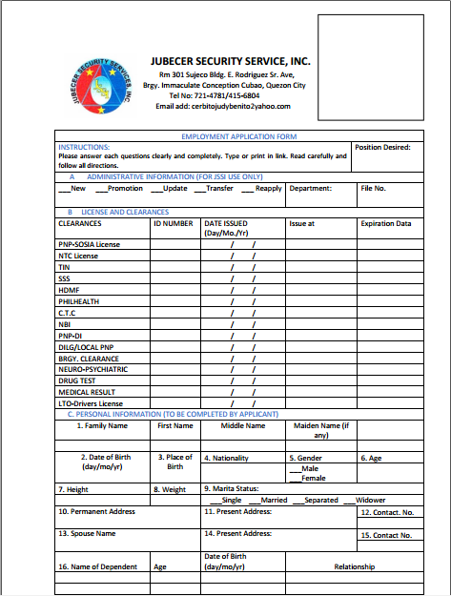

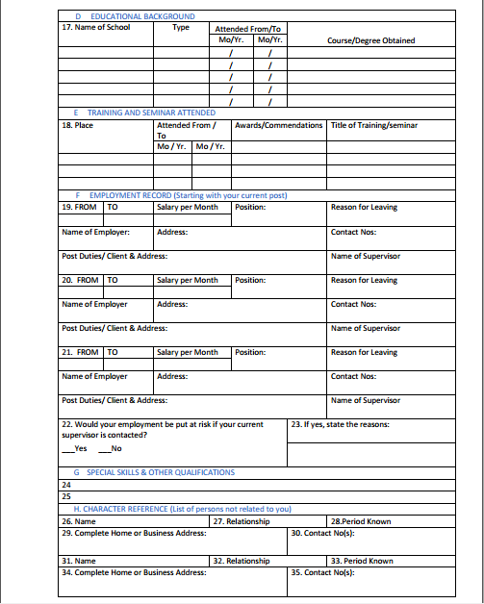

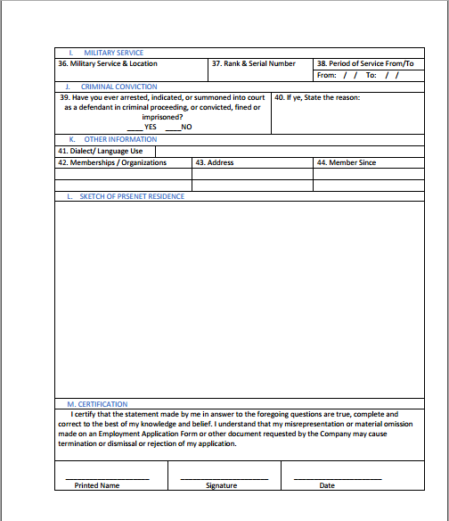

2.) Contract Form

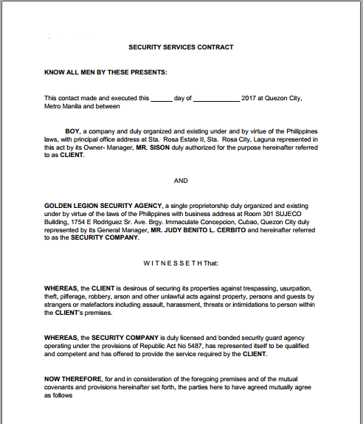

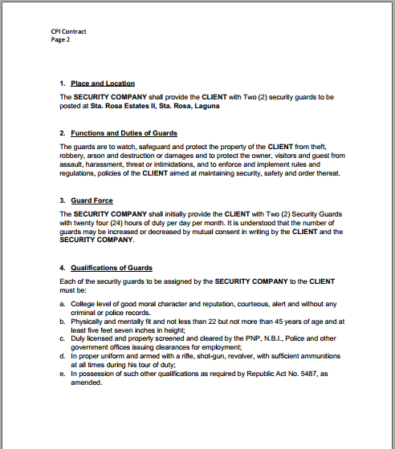

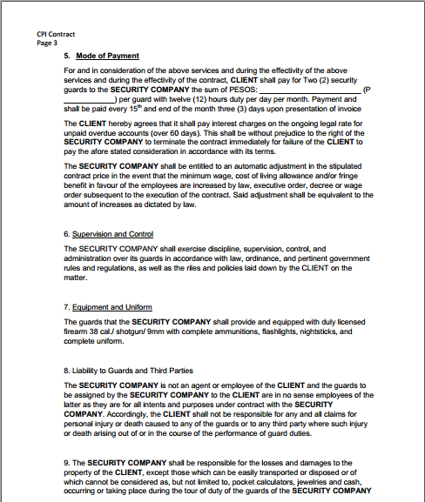

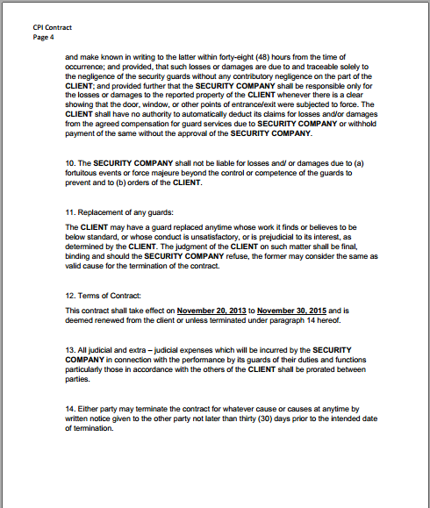

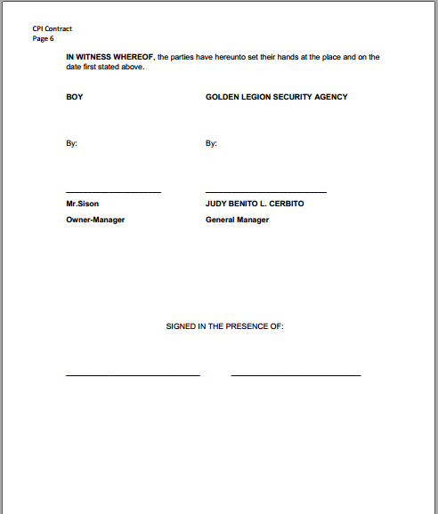

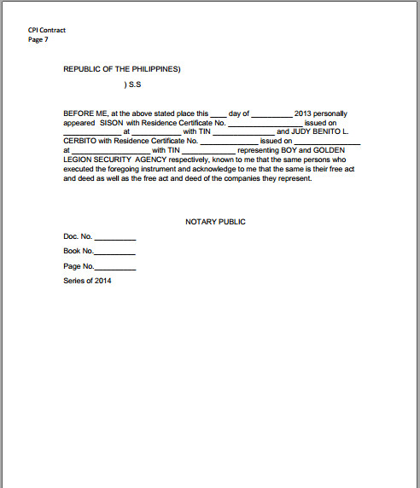

**3.) Individual Application for new Firearm Registration**

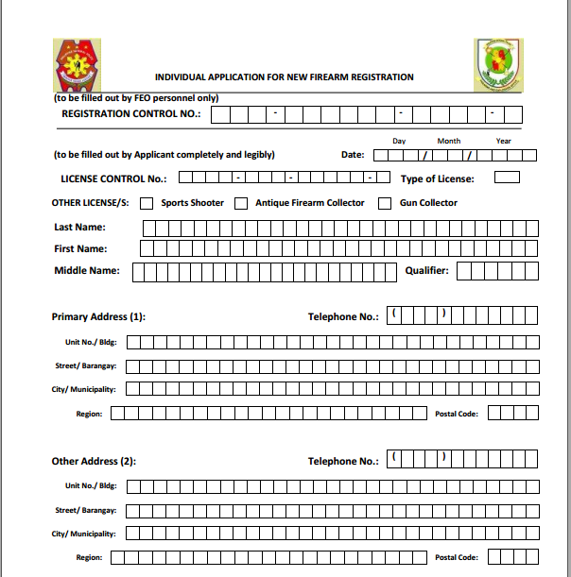

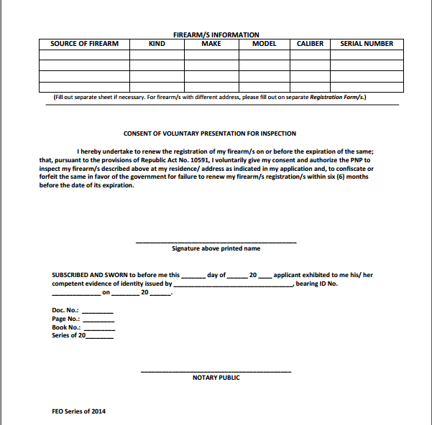

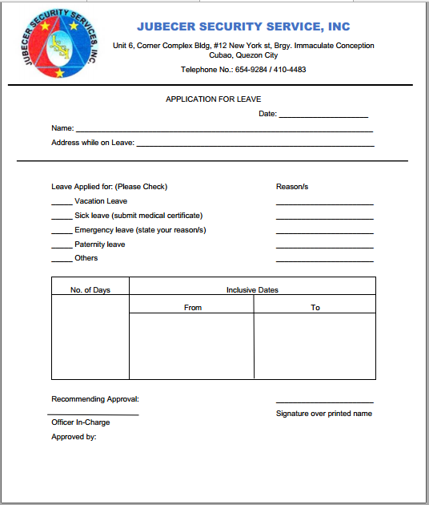4.) Application for Leave

**2.1.2 Reports**

**2.1.2.1 List of Reports**

1. Disposition report - it contains the information about the guards dispose in the respective client.
2. List of officers and their respective designation - it contains the details about list of officers and the location where they are deployed.
3. Gains and Losses -it contains the information regarding the number of newly employed
4. Weekly Time Record – contains the weekly attendance of security guards at their respective posts.

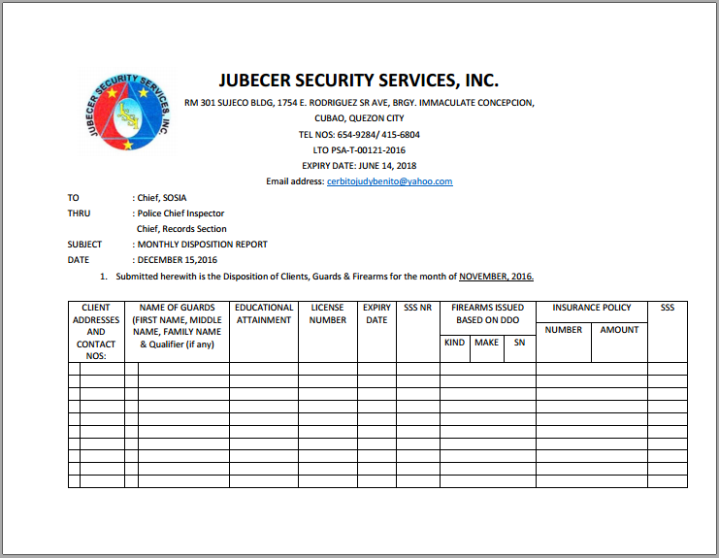**2.1.2.2 Sample Reports**

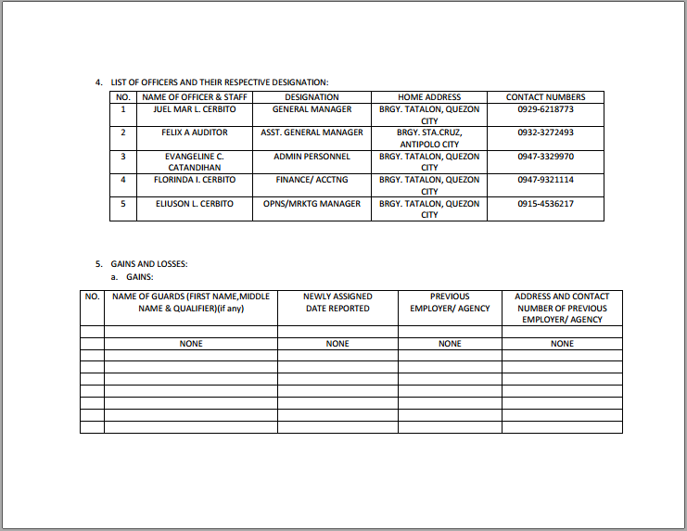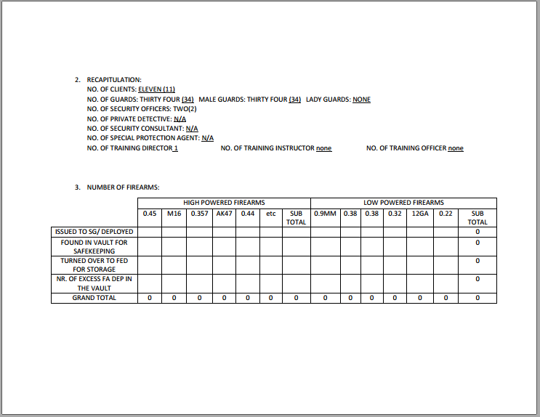

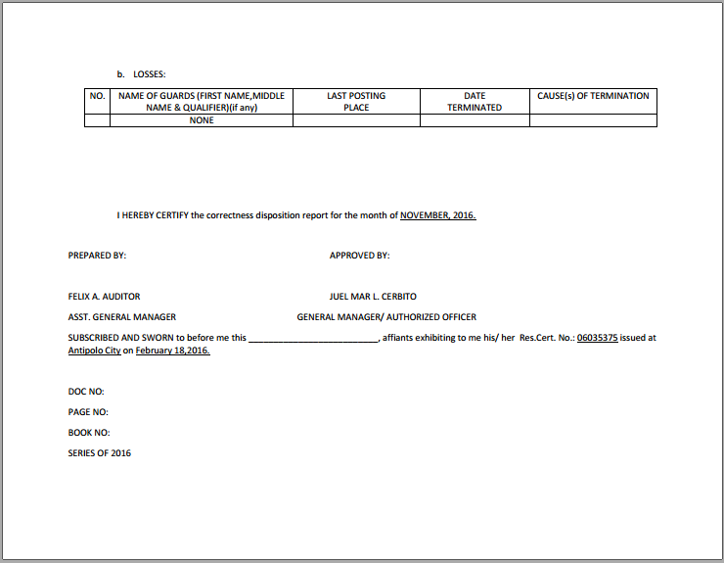

**2.2 Policies and Procedures**

**2.2.1 Procedures**

**2.2.1.1 Context Diagram**

**C:\Users\earldixon\Downloads\cd-2-10-17-4-03pm (4) (1).png**

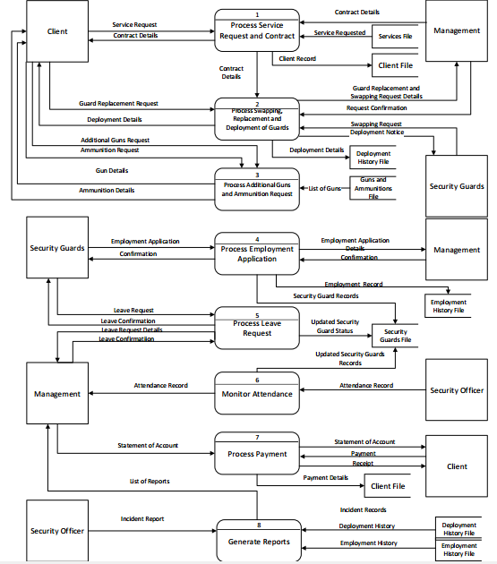**2.2.1.2 Level 1 DFD**

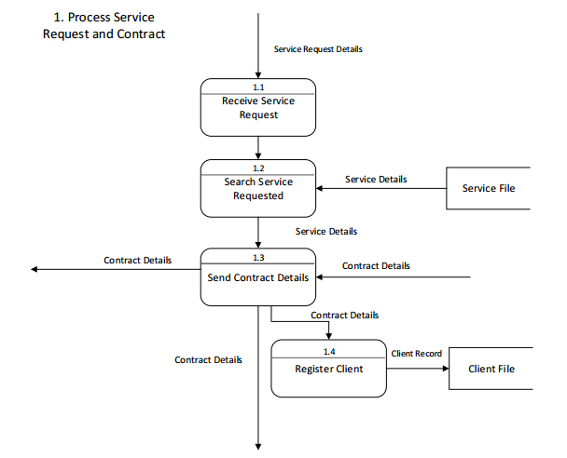

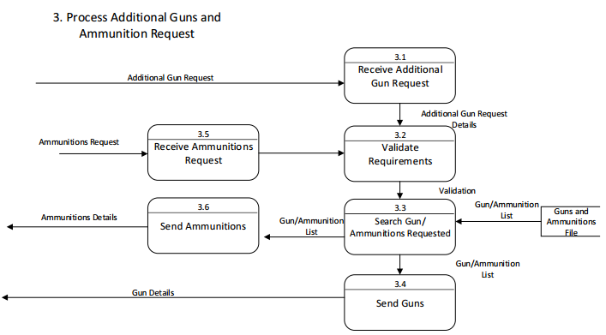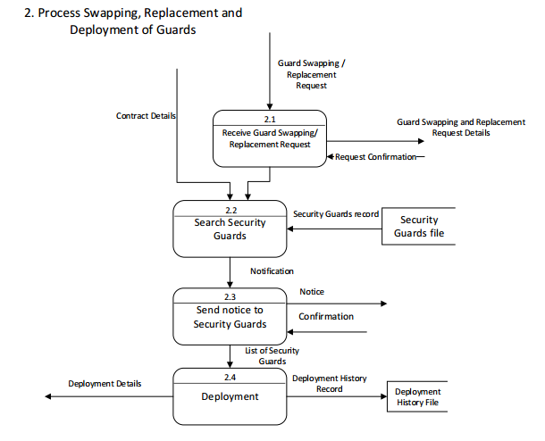

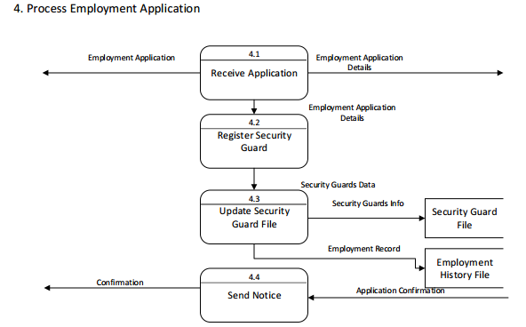

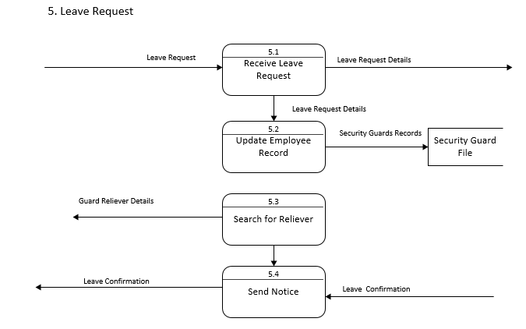

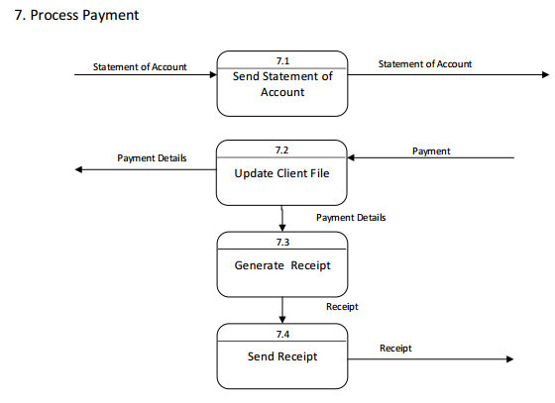

**2.2.2 Policies**

**2.2.2.1 Business Requirements**

|  |  |
| --- | --- |
| **Business Requirement ID** | **Description** |
| BR-001 | The applicant shall submit the  following requirements to the agency:  PNP SOSIA License  NTC License  TIN  SSS  PHILHEALTH  C.T.C.  NBI  PNP-DI  DILG/Local PNP  Brgy. Clearance  Drug Test  Medical Result  LTO Driver’s License |
| BR-002 | The applicant should fill up the  application form provided by the  agency. |
| BR-003 | Pre-qualified applicants are called to  report to the agency’s office for further  assessment and to undergo other  related interviews based on the result  of his written examination, oral  interview, recital of 11 General Orders,  Professional Code of Ethics and  Conduct, and other related questions. |
| BR-004 | Prior to deployment/posting of the  newly hired employees, in the absence  of the HRD Manager, the Personnel  Assistant conduct a briefing and  orients the candidates on the  company profile and organizational |

|  |  |
| --- | --- |
|  | chart, employment status , salaries,  and wages, employee’s welfare,  benefits, health and safety, personnel  security concerns, company policies  and regulations, recruitment,  deployment and termination of  employees, leave benefits, violations  and corresponding penalties,  recognition/awards, conforme/signing,  signifying that she/he fully understood  the aforementioned, and hired  candidate is officially introduced to all  department heads/officers of the  company. |
| BR-005 | Operation Department to conduct  briefings/orientation as to the basic  information concerning the  destination/detachment of the guard,  an introduction of his superior officers,  and the Standard Operating  Procedures (SOP’s) in a specific post  or place of assignment. |
| BR-006 | Guards should be in proper PNP SOA  uniform, complete paraphernalia, and  company patches for they will be  monitored by the operation department  during deployment. |
| BR-007 | Security guards must have a copy of  his duly approved Duty Detail Order  (DDO) to be presented to his superior  officer and the client as well. |

**2.2.2.2 Business Polices**

|  |  |
| --- | --- |
| **Business Policy ID** | **Description** |
| BP-001 | To become security personnel, the  applicant should pass the preliminary  interview, examinations, and  assessment of technical abilities. |
| BP-002 | Preliminary interview must be  conducted by the Psychometrician or  Personnel Assistant. This is to double  check the information written in the  resume as well as assess the  personality of the applicant. |
| BP-003 | All judicial and extra – judicial  expenses which will incurred by the  security company in connection with  the performance by its guards of their  duties and functions particularly those  in accordance with the orders of the  client shall be prorated between  parties. |
| BP-004 | The security company shall not be  liable for losses and/or damages due  to (a) fortuitous events or force  majeure beyond the control or  competence of the guards to prevent  and to (b) orders of the client. |
| BP-005 | The security company shall be  responsible for the losses and  damages to the property of the client,  except those which can be easily  transported or disposed or of which  cannot be considered as, but not  limited to, pocket calculators, jewelries,  and cash, occurring or taking place  during the tour of duty of the guards of  the security company and make known  in writing to the latter within forty-eight  (48) hours from the time of occurrence,  and provided, that such losses or  damages are due to and traceable solely to the negligence of the security  guards without any contributory  negligence on the part of the client;  and provided further that the security  agency shall be responsible only for  the losses or damages to the reported  property of the client whenever there is  a clear showing that the door, window,  or other points of entrance/exit were  subjected to force. |

|  |  |
| --- | --- |
| BP-006 | The client shall have no authority to  automatically deduct its claims for  losses and/or damages from the  agreed compensation for guard  services due to Security Company or  withhold payment of the same without  the approval of the security company. |
| BP-007 | Security guards in his duty must be in  SG prescribed uniform and shall carry  the issued firearm only when there are  in actual performance of guard duty  within the compound of the  establishment or property of their client  in the place and time specified in the  Duty Detail Order. |
| BP-008 | Duty Detail Order is not an authority for  security guards to carry their issued  firearm outside the premises of the  specified post/station nor shall the  firearm described herein leave the  client post/station. |
| BP-009 | The guards are to watch, safeguard  and protect the property of the client  from theft, robbery, arson, and  destruction or damages and to protect  the owner, visitors and guests from  assault, harassment, threat or  intimidation, and to enforce and  implement rules and regulations,  policies of the client aimed at  maintaining security, safety, and order  thereat. |
| BP-010 | Clients can avail the agency’s  services with a contract form. Clients  have to approach the agency in  personal to do the transactions and  other business processes related to  the service. The management of the  client and the management of the  agency must talk to each other, in  order to settle the agreed contract. |

**2.3 Problem Analysis**

**2.3.1 Fishbone**

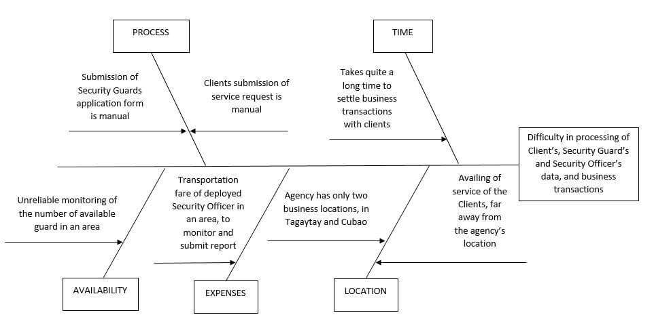

**2.3.2 Conclusion**

The problems stated on the fishbone diagram are the main cause for the unsystematic handling of business resources which is the main problem encountered by the agency on their entire business process using the manual transactions and paper works. Using manual methods of recording their clients and employee records and keeping it on a folder makes the process time consuming and requires more effort. The data also are not secured and more prone to damage and loss. The manual process also requires lots of forms to be kept and requires more effort to handle and maintain. They monitor attendance of security guards by going to their clients one by one which requires more time and efforts to visit each client just to monitor the attendance. The unsystematized workflow of their business process causes the entire transaction to run slow and unorganized. Based on those problems and other data gathered, the proponents conclude that the Jubecer Security Service, Inc is in need of an online system and have come up with the appropriate solution. The proponents have devised a system that will streamline the procedure of processing the business transactions with an online management information system.

**2.3.3 Recommendations**

In this generation there is an increasing demand for a faster and more high tech way of processing or doing any kind of transactions. Nowadays most of the Security Agencies provide their services using web-based system. It helps to perform task in an easy way with less time consumed. Some companies are become fully automated while others strive for the manual procedure on making reservations. Jubecer Security Services, Inc manual transactions processing is outdated, worn down, and cannot be expected to be applied to the increasing demand for a higher and much better services. Based on the stated conclusion the proponents recommend the use of online management system with the following features and modules.

1. Security module- Increasing the security and confidentiality of each files and report by providing a security module, a log-in form that will have three (3) levels of access. The first will be the administrator of the system, the Employees will be the second, and the customers for the third level of access. Each will have a unique username and password thus making the system more secured not only for the company but also to other users of the system.
2. MySQL- With the implementation of MySQL as the systems back end which is more advance and has additional features compare to other databases, the company will have the benefit of a less expensive data storage because it is popular and free to download in addition it is very customizable, the user can customize its function with the knowledge of technical know-how. Furthermore, data’s that are stored in MySQL are accessible and can be easily manipulated with a basic knowledge of Structured Query Language (SQL) which is easy to learn and use, and is available on different operating systems moreover creating backup for the saved data’s will provide ease for every user of the system.
3. Maintenance module- The system will provide a maintenance module which is accessible only by the admin. With this, the admin can easily view and manage all information flowing within the system. The admin can view the list of their clients, employees, and manage their information. The admin can also view all of the contract and their status, see who security guards are available, and the list of deployed guards. With this module, modifying the data within the system is no longer a problem.
4. Search module- Searching and retrieving of records would be easier since there would be a search module that would filter all the needed records. Having a search module will lessen the time of looking for records that is done manually on the existing system.
5. Online web-based management system- Upgrading to online web-based system will help the company to increase their exposure to other possible client/s. Moreover, the website will have twenty-four (24) hours access for end users. Aside from increasing the company’s exposure, this will also serve as their competitive marketing strategy promotion of their company to overcome the other competitor’s innovation.

**CHAPTER 3**

**PROPOSED SYSTEM DEFINITION**

**3.1 Functional Specification**

**3.1.1 System Boundaries**

**3.1.1.1 System Use Case Diagram**

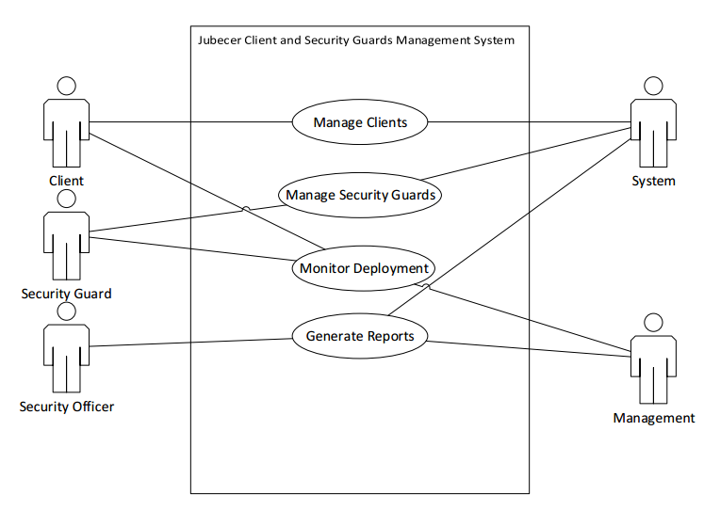

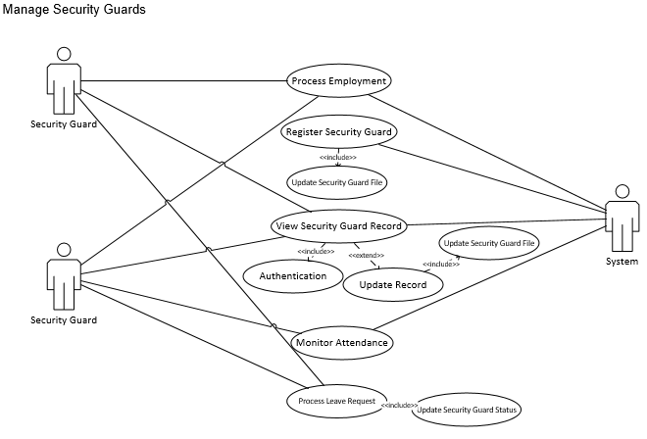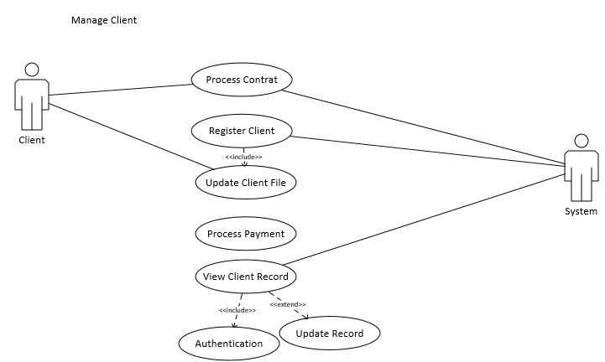**3.1.1.2 Detailed Use Case Diagram**

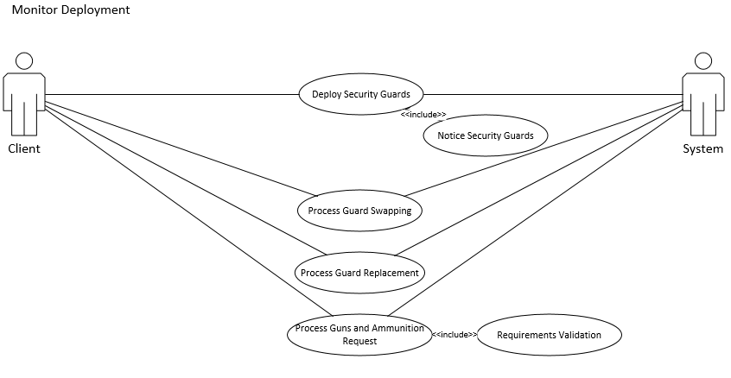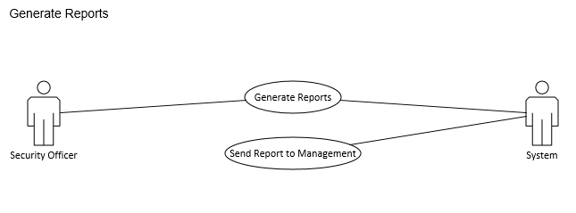

* + 1. System Flow
       - 1. <Per Module>

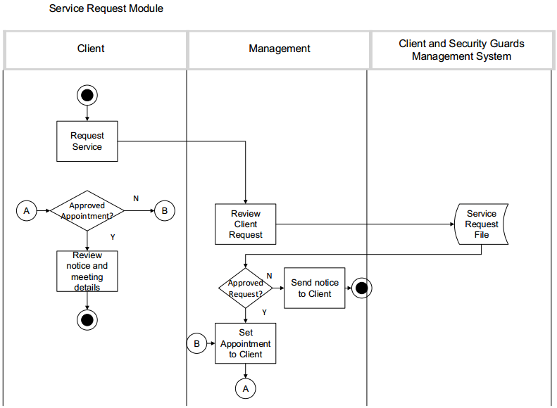

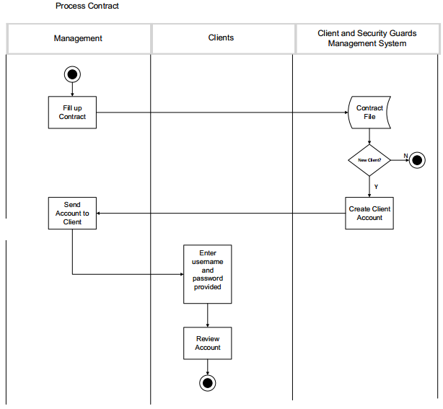

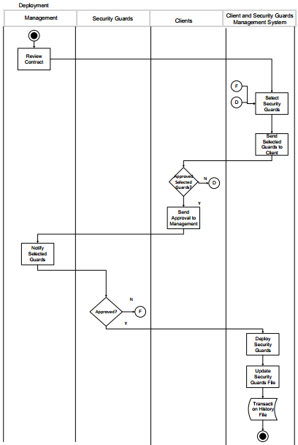

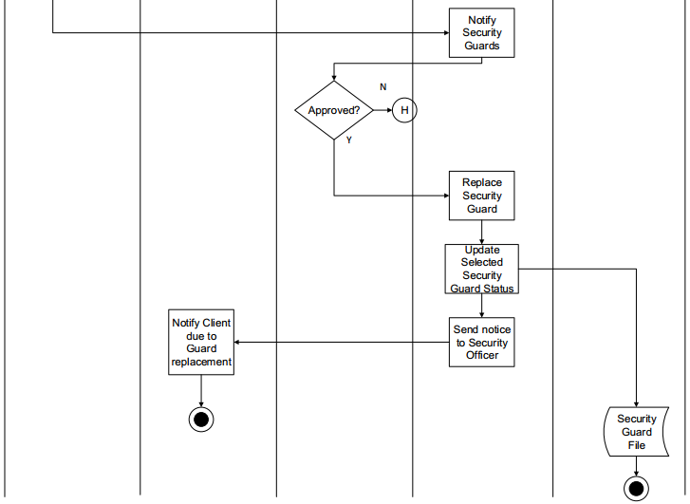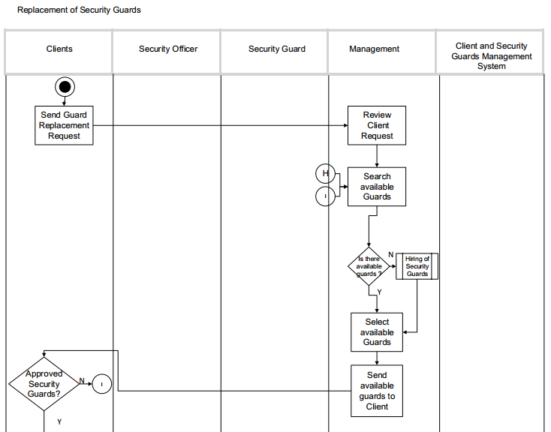

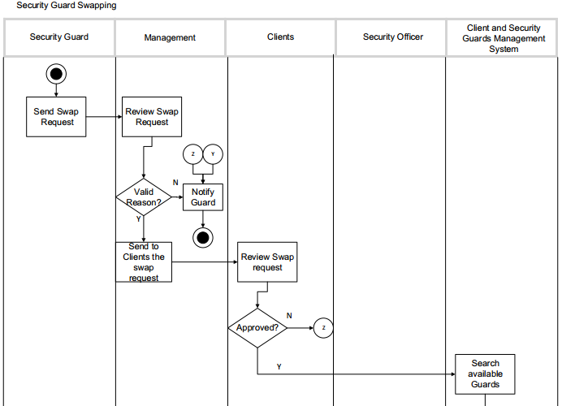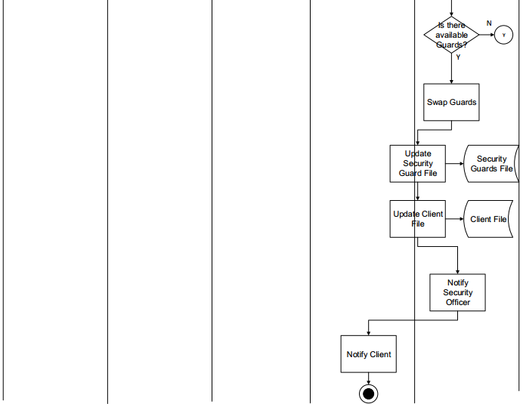

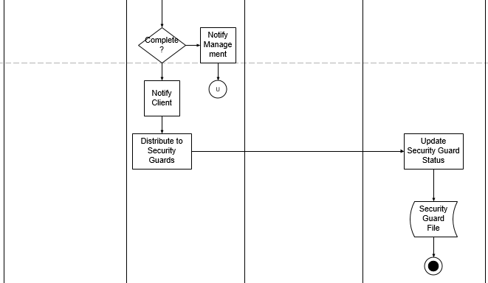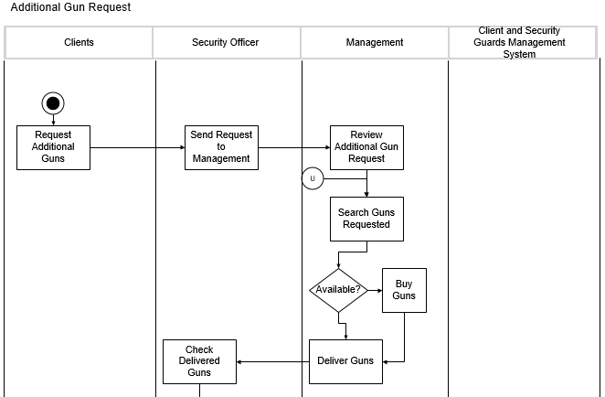

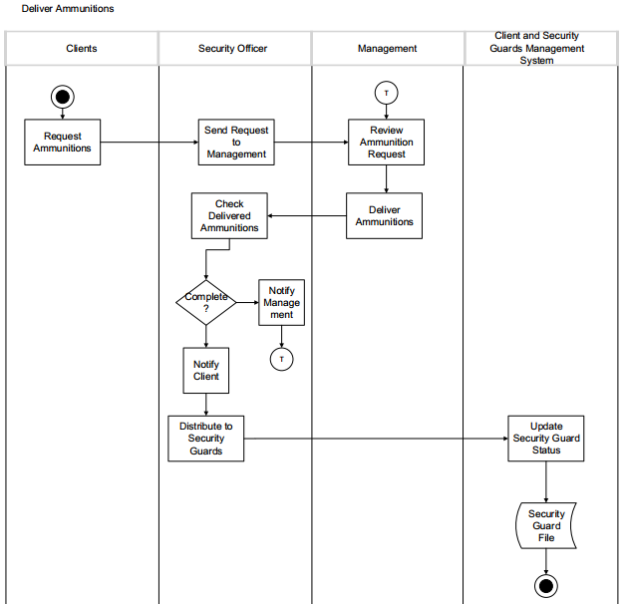

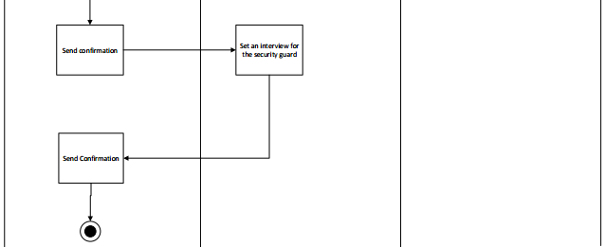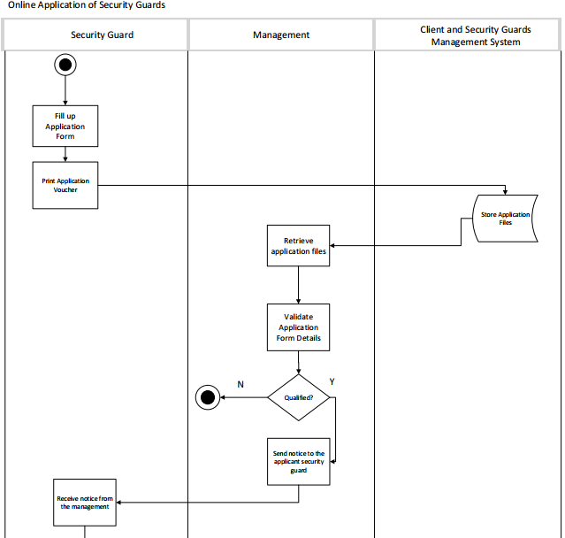

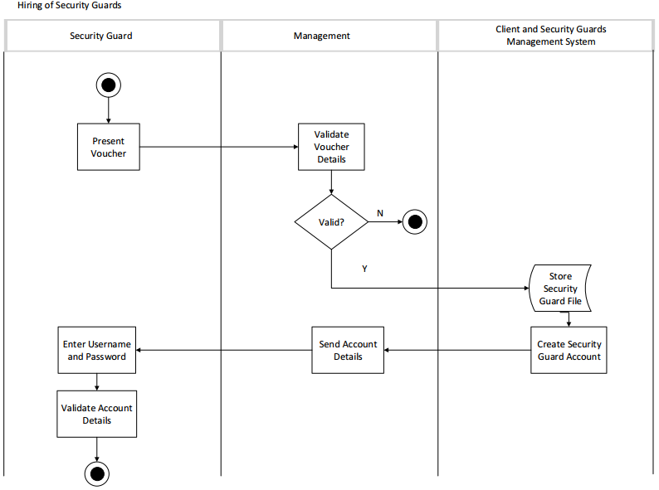

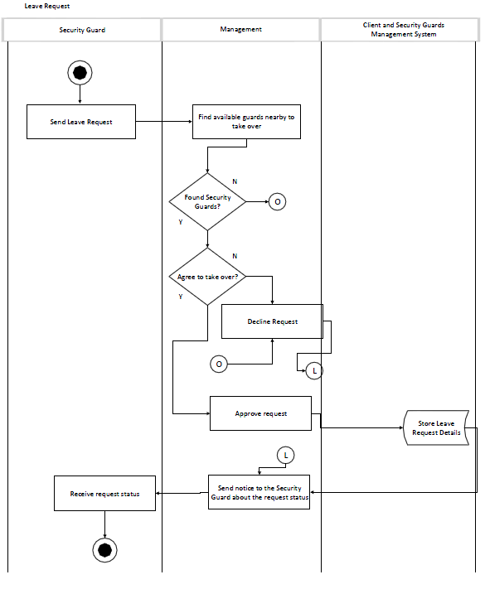

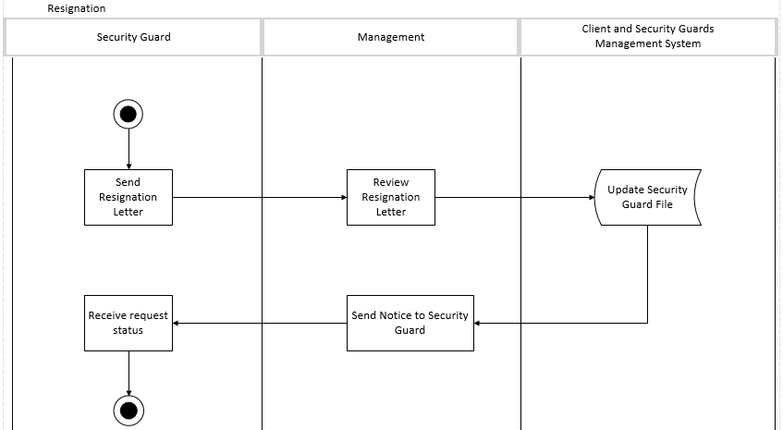

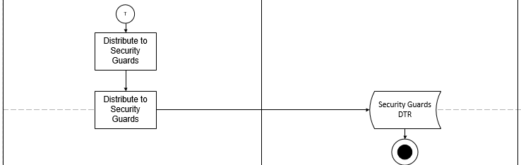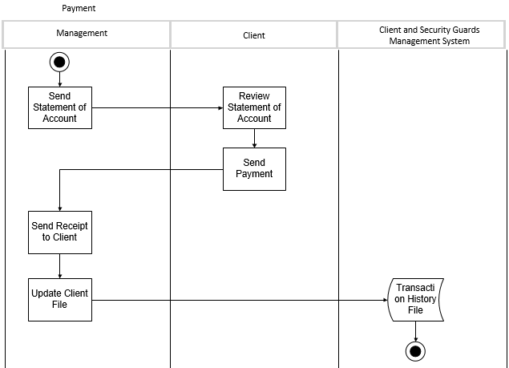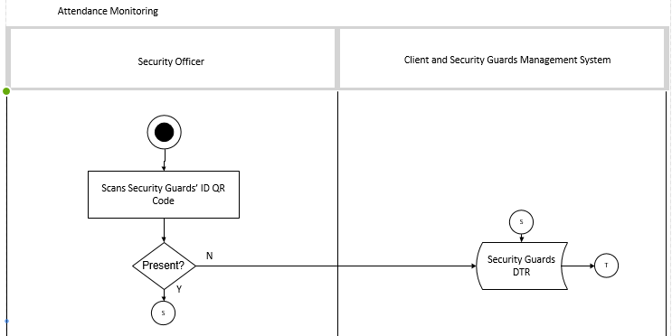

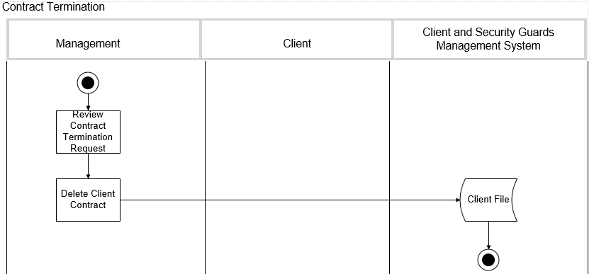

* 1. **Technical Specification**

**3.2.1 Domain Object Modelling**

**3.2.1.1 Data Dictionary of Classes**

|  |  |  |  |  |
| --- | --- | --- | --- | --- |
| FieldName | Description | Type | Length | Sample |
| id | Client Code | VARCHAR | 45 | CLIENT001A |
| strClientName | Client Name | VARCHAR | 45 | BDO |
| strClientAddress | Client Address | TEXT |  | 34 Baguio St. Bago Bantay |
| AreaCode | Area Code | VARCHAR | 45 | MNL001A |
| tblArea | | | |  |
| Description: This contains the location used for maintenance | | | | |
| FieldName | Description | Type | Length | Sample |
| id | Area Code | VARCHAR | 45 | MNL001A |
| strArea | Area | VARCHAR | 45 | MANILA |
| tblServices | | | |  |
| Description: This table contains all details the agency offer to their clients | | | | |
| FieldName | Description | Type | Length | Sample |
| id | Service Code | VARCHAR | 45 | SERV001A |
| strServiceType | Service Type | VARCHAR | 45 | Commercial Security |
| tblRenewalRequest | | | |  |
| Description: This contains information about the contract renewal of the client | | | | |
| FieldName | Description | Type | Length | Sample |
| id | Renewal Request Code | VARCHAR | 45 | RENWL001A |
| strStatus | Status of Renewal Request | VARCHAR | 45 | Approved |
| ClientCode | Client Code | VARCHAR | 45 | CLIENT001A |
| tblClientUser | | | |  |
| Description: This contains the usename and password of the client | | | | |
| FieldName | Description | Type | Length | Sample |
| id | Client Code | VARCHAR | 45 | CLIENT001A |
| strUsername | Client Username | VARCHAR | 45 | Ernest.BDO |
| strPassword | Client Password | VARCHAR | 45 | adminernest |
| tblGunRequest | | | |  |
| Description: Contains the details about the gun request of the client | | | | |
| FieldName | Description | Type | Length | Sample |
| id | Gun Request Code | VARCHAR | 45 | GUNREQ001A |
| strStatus | Status of Gun Request | VARCHAR | 45 | Approved |
| GunCode | Gun Code | VARCHAR | 45 | CLBR45001A |
| ClientCode | Client Code | VARCHAR | 45 | CLIENT001A |
| tblGun | | | |  |
| Description: Contains all informations about the guns | | | | |
| FieldName | Description | Type | Length | Sample |
| intGunCode | Gun Code | INT |  | CLBR45001A |
| strGunName | Name of Gun | VARCHAR | 45 | CALIBER 45 |

**C:\Users\earldixon\Desktop\Overnight\Class Diagram.png3.2.1.2 Final Class Diagram**

**3.2.2 Database Design**

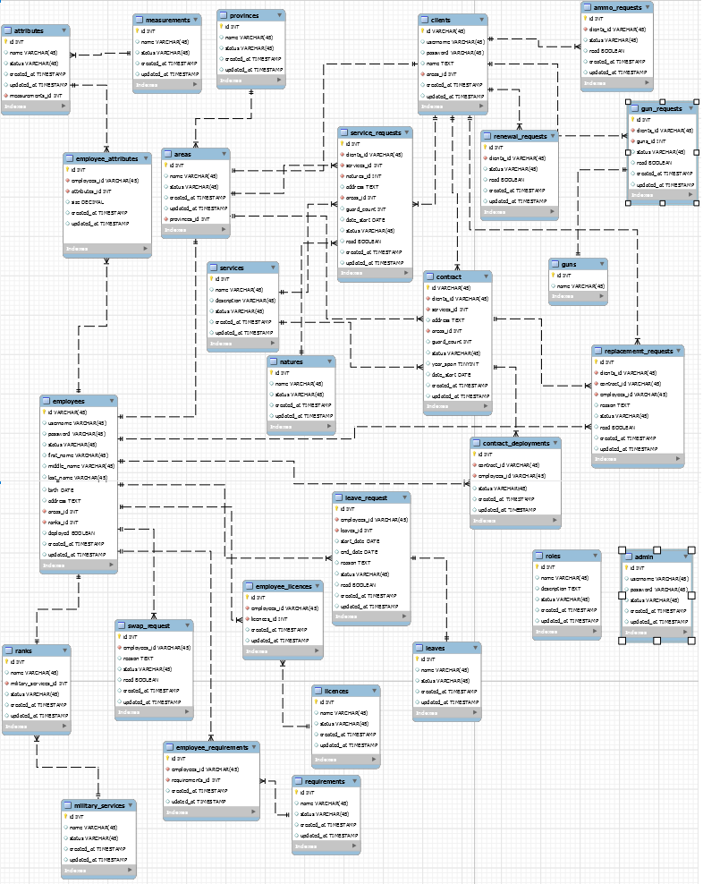**3.2.2.1 Database Schema**

**3.2.2.2 Database Dictionary**

|  |  |  |  |  |
| --- | --- | --- | --- | --- |
| tblEmpUser | | | |  |
| FieldName | Description | Type | Length | Sample |
| id | Employee Code | VARCHAR | 45 | EMP001A |
| strEmpUsername | Employee Username | VARCHAR | 45 | luigi04 |
| strEmpPassword | Employee Password | VARCHAR | 45 | password12345 |
| tblRank | | | |  |
| FieldName | Description | Type | Length | Sample |
| id | Rank Code | VARCHAR | 45 | SO001A |
| strRank | Rank | VARCHAR | 45 | Security Officer |
| tblResignationRequest | | | |  |
| FieldName | Description | Type | Length | Sample |
| id | Resignation Request Code | INT |  | RESGN001A |
| strStatus | Status of Resignation Request | VARCHAR | 45 | Approved |
| intEmpCode | Employee Code | VARCHAR |  | EMP001A |
| tblReplacementRequest | | | |  |
| FieldName | Description | Type | Length | Sample |
| id | Replacement Request Code | VARCHAR | 45 | REP001A |
| strReason | Reason of Replacement Request | Text |  | Always absent |
| EmpCode | Employee Code | VARCHAR | 45 | EMP001A |
| ClientCode | Client Code | VARCHAR | 45 | CLIENT001A |
| tblDeployment | | | |  |
| FieldName | Description | Type | Length | Sample |
| id | Deployment Code | VARCHAR | 45 | DPLY001A |
| EmpCode | Employee Code | VARCHAR | 45 | EMP001A |
| ClientCode | Client Code | VARCHAR | 45 | CLIENT001A |
| ContractCode | Contract Code | VARCHAR | 45 | CNTRCT001A |
| tblEmpDetail | | | |  |
| FieldName | Description | Type | Length | Sample |
| id | Employee Code | VARCHAR | 45 | EMP001A |
| strFirst | First Name | VARCHAR | 45 | luigi04 |
| strLast | Last Name | VARCHAR | 45 | Lacsina |
| strMiddle | Middle Name | VARCHAR | 45 | Mandap |
| strAddress | Address | TEXT |  | 26 Palawan St. Bago Bantay |
| AreaCode | Area Code | VARCHAR | 45 | MNL001A |
| RankCode | Rank Code | VARCHAR | 45 | SO001A |
| tblLeaveRequest | | | |  |
| FieldName | Description | Type | Length | Sample |
| id | Leave Request Code | VARCHAR | 45 | LVREQ001A |
| strStatus | Status of Leave Request | VARCHAR | 45 | Approved |
| EmpCode | Employee Code | VARCHAR | 45 | EMP001A |
| tblMessage | | | |  |
| FieldName | Description | Type | Length | Sample |
| id | Message Code | INT |  | MSSG001A |
| EmpCode | Employee Code | VARCHAR | 45 | EMP001A |
| AdminCode | Admin Code | VARCHAR | 45 | ADMIN001A |
| strTitle | Message Title | VARCHAR | 45 | Report for January 25, 2017 |
| strMessage | Message Body | TEXT |  | Security guards are performing great. |
| tblTermination | | | |  |
| FieldName | Description | Type | Length | Sample |
| id | Termination Code | VARCHAR | 45 | TRMNT001A |
| ContractCode | Contract Code | VARCHAR | 45 | CNTRCT001A |
| ClientCode | Client Code | VARCHAR | 45 | CLIENT001A |
| tblContract | | | |  |
| FieldName | Description | Type | Length | Sample |
| id | Contract Code | VARCHAR | 45 | CNTRCT001A |
| strContractName | Contract Name | VARCHAR | 45 | SERVICE CONTRACT |
| intYears | Years | INT |  | 3 |
| ClientCode | Client Code | VARCHAR | 45 | CLIENT001A |
| tblServiceRequest | | | |  |
| FieldName | Description | Type | Length | Sample |
| id | Service Request Code | VARCHAR | 45 | SERVREQ001A |
| intPersonnelNumbers | Number of Requested Guards | INT |  | 5 |
| ClientCode | Client Code | VARCHAR | 45 | CLIENT001A |
| ServiceCode | Service Code | VARCHAR | 45 |  |
| tblAdmin | | | |  |
| FieldName | Description | Type | Length | Sample |
| id | Admin Code | VARCHAR | 45 | ADMIN001A |
| strAdminUsername | Admin Username | VARCHAR | 45 | bela001a |
| strAdminPassword | Admin Password | VARCHAR | 45 | abelxxx |
| tblClient | | | |  |
| FieldName | Description | Type | Length | Sample |
| id | Client Code | VARCHAR | 45 | CLIENT001A |
| strClientName | Client Name | VARCHAR | 45 | BDO |
| strClientAddress | Client Address | TEXT |  | 34 Baguio St. Bago Bantay |
| AreaCode | Area Code | VARCHAR | 45 | MNL001A |
| tblArea | | | |  |
| FieldName | Description | Type | Length | Sample |
| id | Area Code | VARCHAR | 45 | MNL001A |
| strArea | Area | VARCHAR | 45 | MANILA |
| tblServices | | | |  |
| FieldName | Description | Type | Length | Sample |
| id | Service Code | VARCHAR | 45 | SERV001A |
| strServiceType | Service Type | VARCHAR | 45 | Commercial Security |
| tblRenewalRequest | | | |  |
| FieldName | Description | Type | Length | Sample |
| id | Renewal Request Code | VARCHAR | 45 | RENWL001A |
| strStatus | Status of Renewal Request | VARCHAR | 45 | Approved |
| ClientCode | Client Code | VARCHAR | 45 | CLIENT001A |
| tblClientUser | | | |  |
| FieldName | Description | Type | Length | Sample |
| id | Client Code | VARCHAR | 45 | CLIENT001A |
| strUsername | Client Username | VARCHAR | 45 | Ernest.BDO |
| strPassword | Client Password | VARCHAR | 45 | adminernest |
| tblGunRequest | | | |  |
| FieldName | Description | Type | Length | Sample |
| id | Gun Request Code | VARCHAR | 45 | GUNREQ001A |
| strStatus | Status of Gun Request | VARCHAR | 45 | Approved |
| GunCode | Gun Code | VARCHAR | 45 | CLBR45001A |
| ClientCode | Client Code | VARCHAR | 45 | CLIENT001A |
| tblGun | | | |  |
| FieldName | Description | Type | Length | Sample |
| intGunCode | Gun Code | INT |  | CLBR45001A |
| strGunName | Name of Gun | VARCHAR | 45 | CALIBER 45 |

**3.2.3 Screen Design**

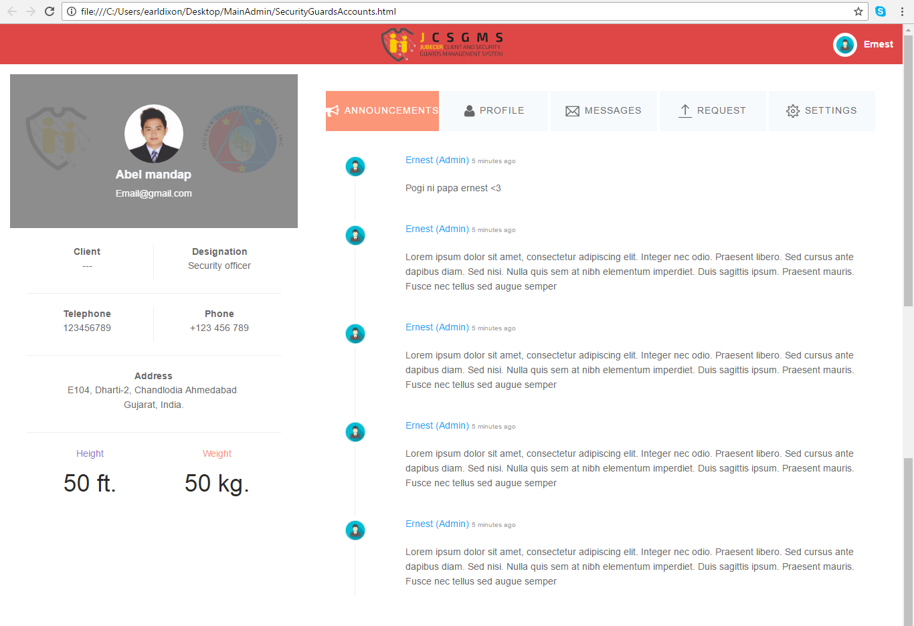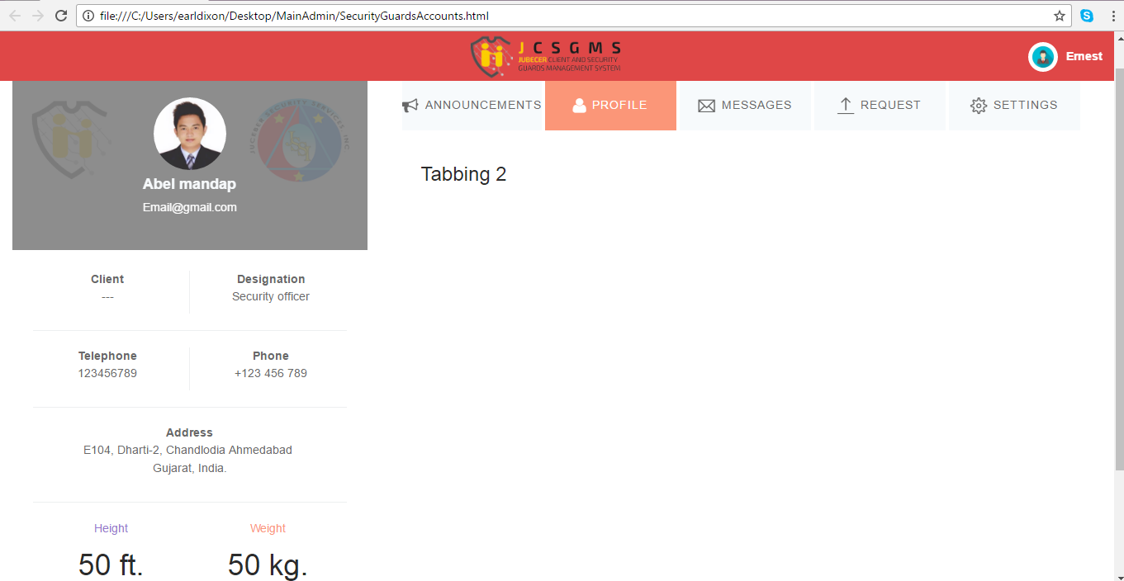Main Admin

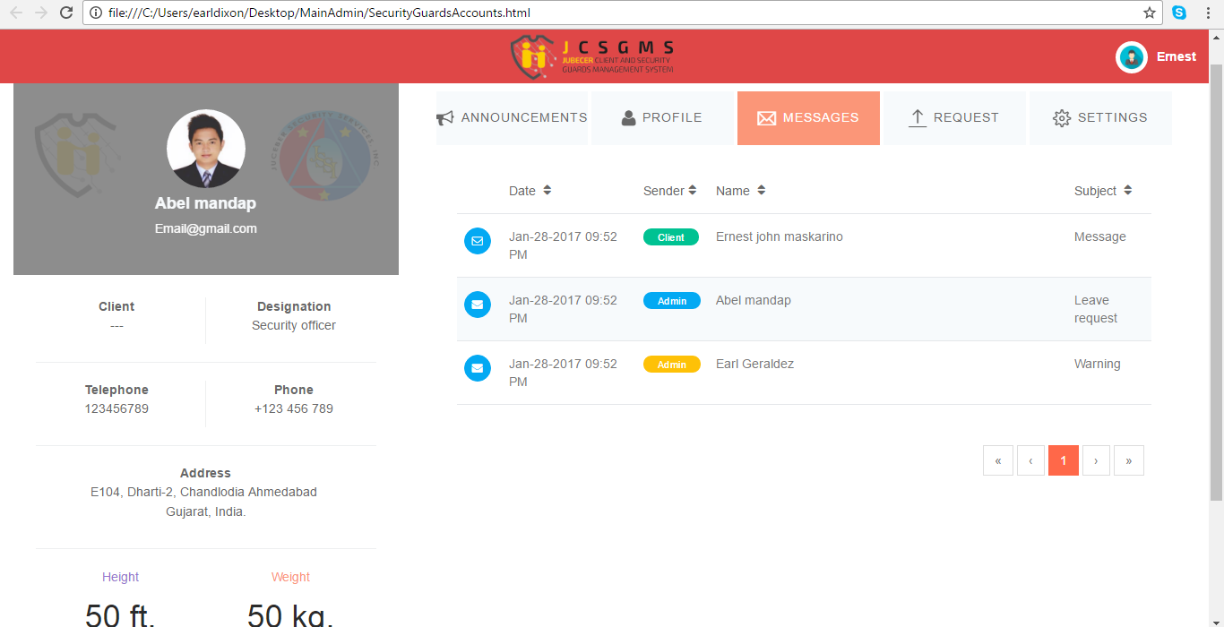

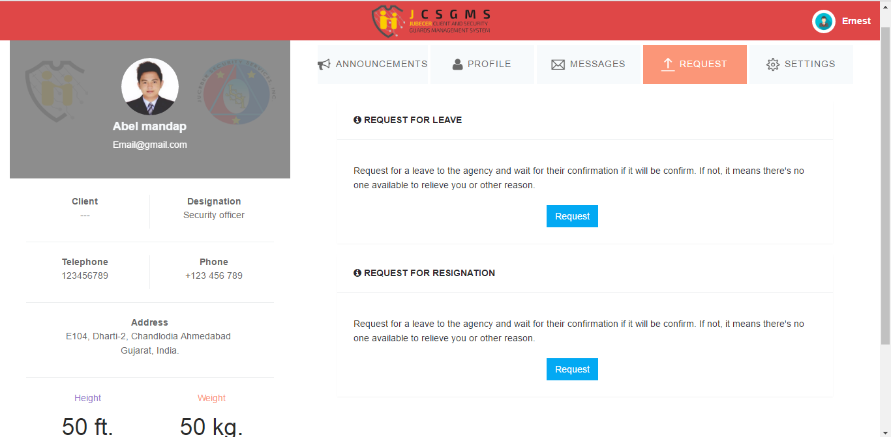

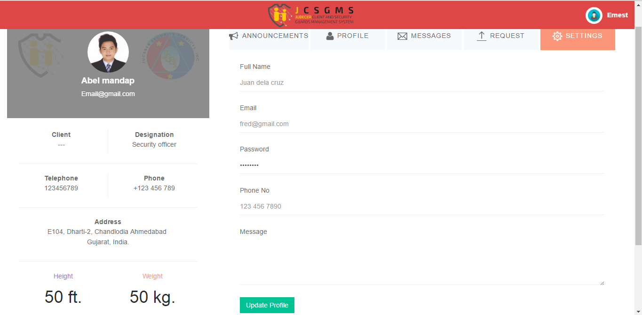

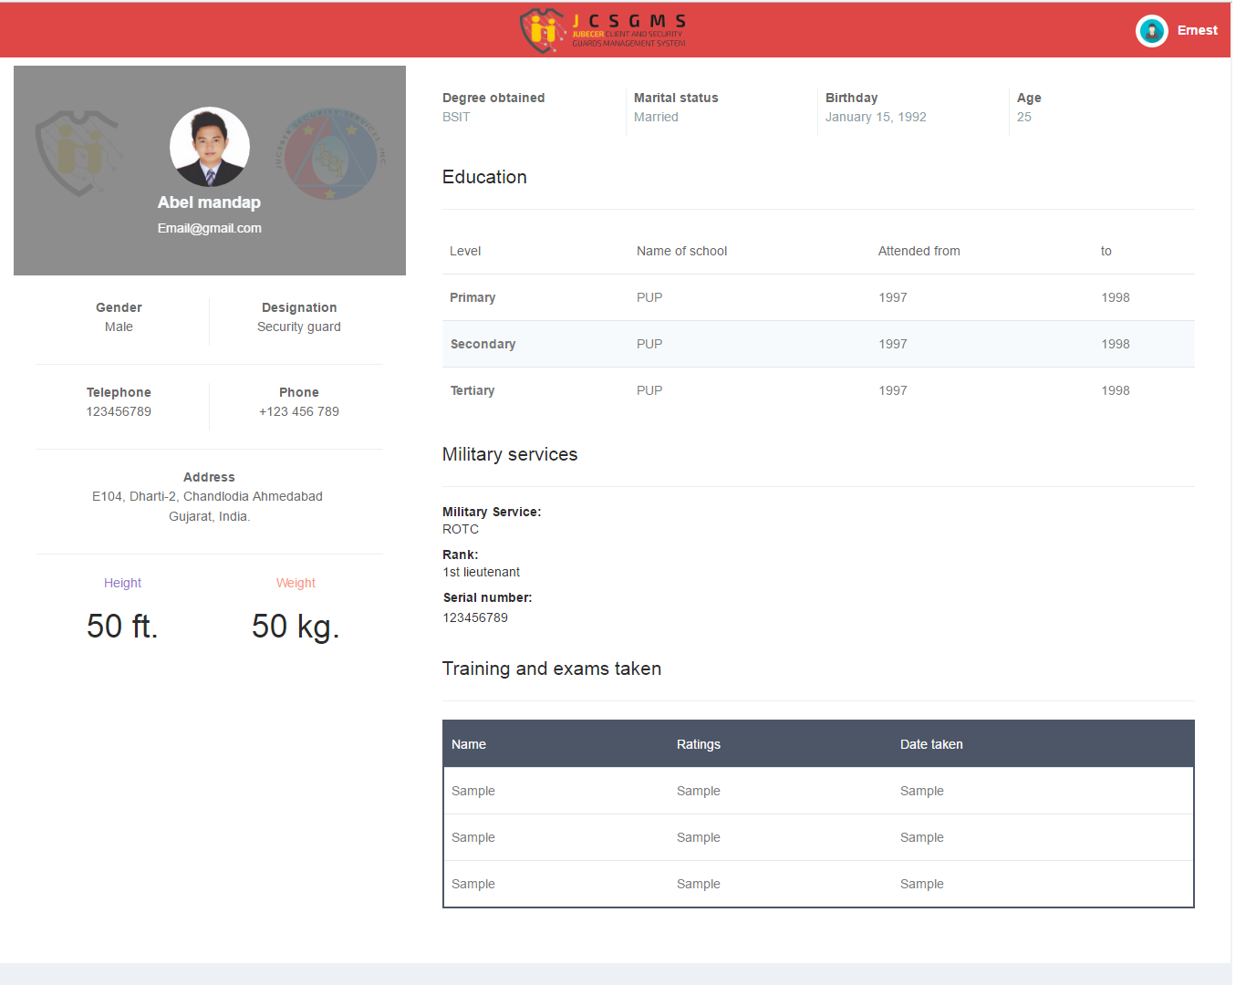Security Guard Profile

Select Security Guards

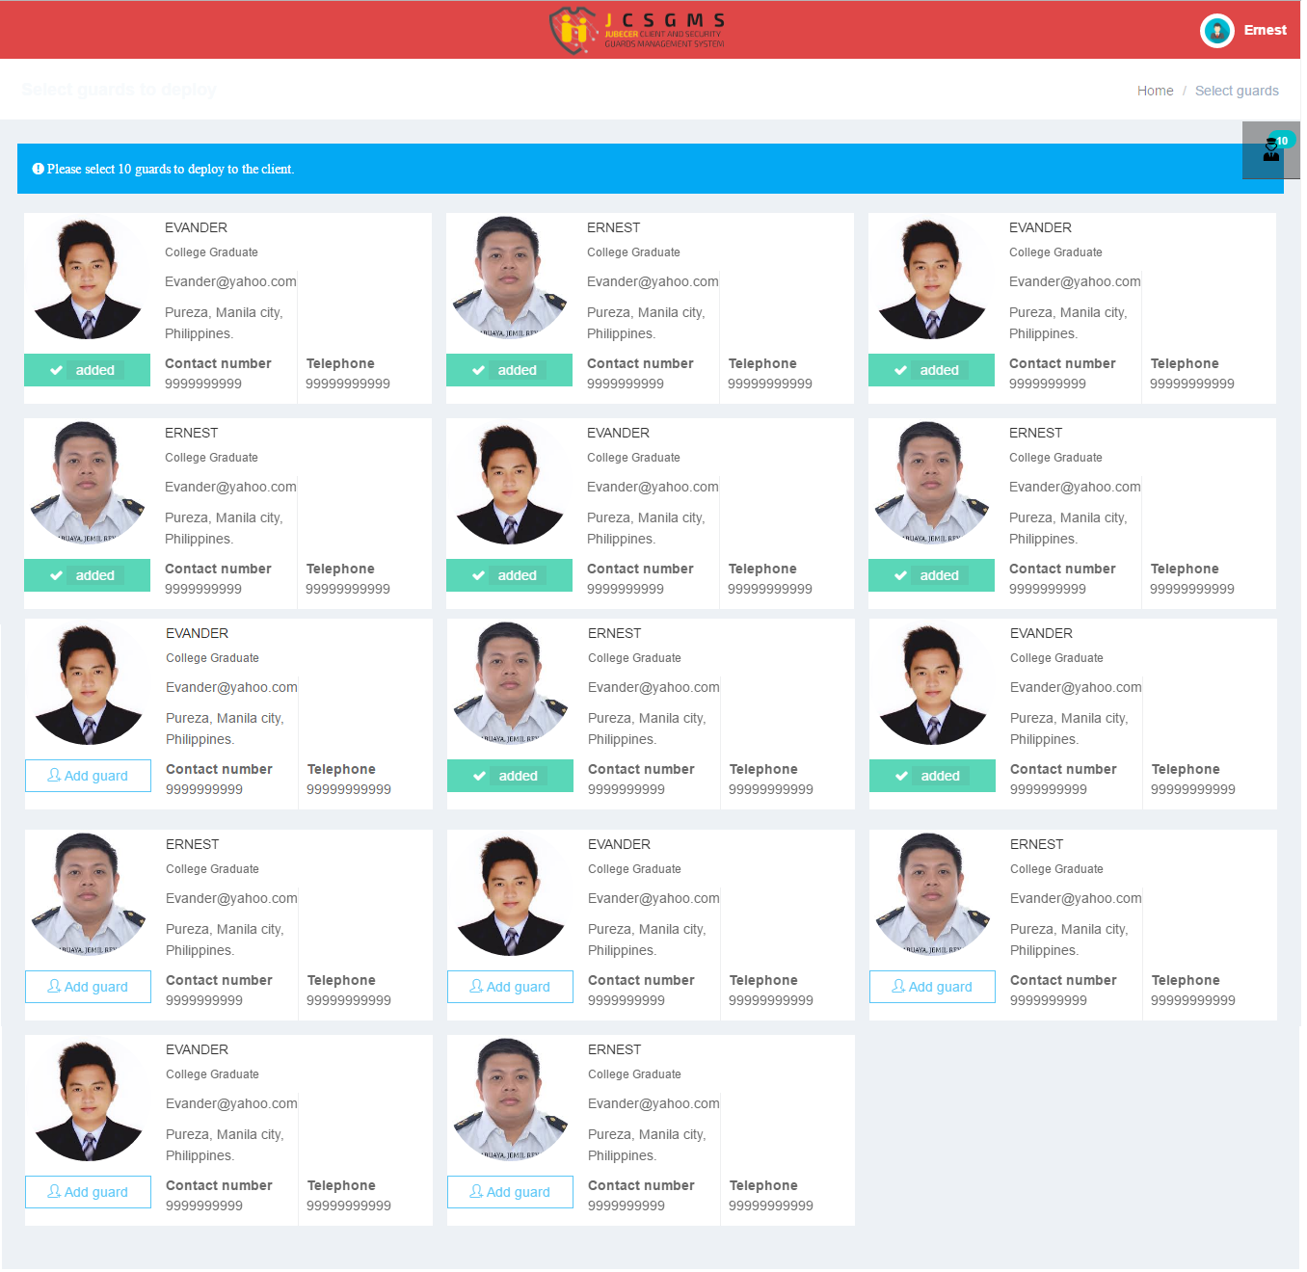

Employment Application

